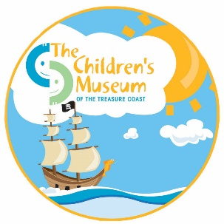

PHOTO USE RELEASE FORM

I,__________________________________________ , hereby grant and authorize The Children's Museum of the Treasure Coast, Inc. the right to take, edit, alter, copy, exhibit, publish, distribute and make use of any and all pictures or video taken of me and/r my minor child to be used in and/or for legally promotional materials including, but not limited to, newsletters, flyers, posters, brochures, advertisements, fundraising letters, annual reports, press kits and submissions to journalists, websites, social networking sites and other print and digital communications, without payment or any other consideration. This authorization extends to all languages, media, formats and markets now known or hereafter devised. This authorization shall continue indefinitely, unless I otherwise revoke said authorization in writing.

I understand and agree that these materials shall become the property of The Children's Museum of the Treasure Coast, Inc. and will not be returned.

I hereby hold harmless, and release The Children's Museum Of The Treasure Coast, Inc. from all liability, petitions, and causes of action which I, my heirs, representative, executors, administrators, or any other persons may make while acting on my behalf or on behalf of my estate.

I warrant that I am of the age of consent (18 years or older) and that I am competent to contract in my own name. I have read this release before signing below and I fully understand the contents, meaning and impact of this release.

_________________________________________________ ___________________________
(Signature) (Date)

